**Defined Functions in Python Programming Language**

**Kevin Karanja Wachira**

**Naivasha,2023**

**Purpose:**

* Be able to create a sub program in the main program
* Be able to call and reuse a function
* Avoid repetition of a code which is very tiresome in programming

**Theory:**

A function is a block of code which only runs when it is called.You can pass data, known as parameters, into a function.A function can return data as a result.

There are two types of function in python i.e user defined function and built-in function .User defined function are defined by the user to perform any specific task. built-in function are pre-defined in python. In Python a function is defined using the def keyword. To call a function, use the function name followed by parenthesis

A parameter is the variable listed inside the parentheses in the function definition.An argument is the value that is sent to the function when it is called.

By default, a function must be called with the correct number of arguments. Meaning that if your function expects 2 arguments, you have to call the function with 2 arguments, not more, and not less.

You can send any data types of argument to a function (string, number, list, dictionary etc.), and it will be treated as the same data type inside the function.E.g. if you send a List as an argument, it will still be a List when it reaches the function.

**Task:**

Find value of B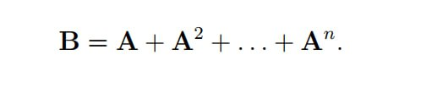

**Solution:**

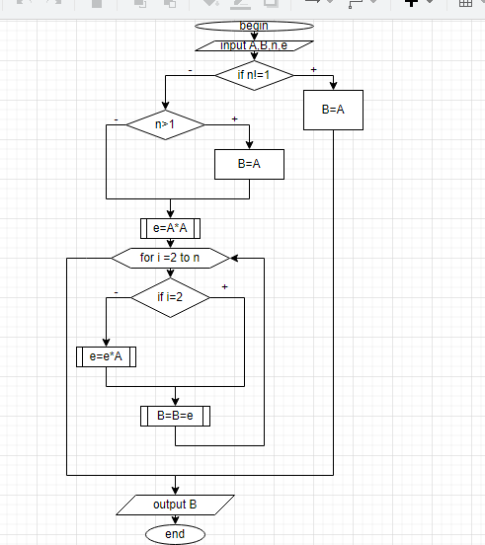

**Code:**

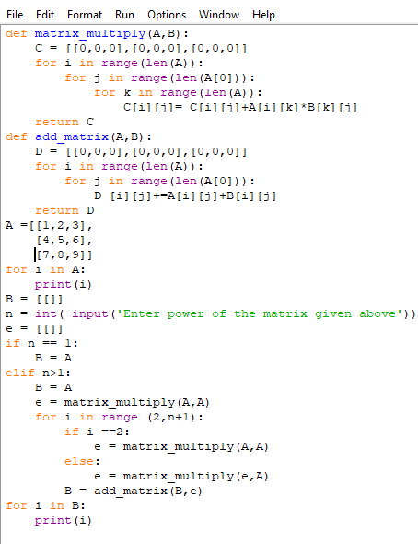

**Test data:** 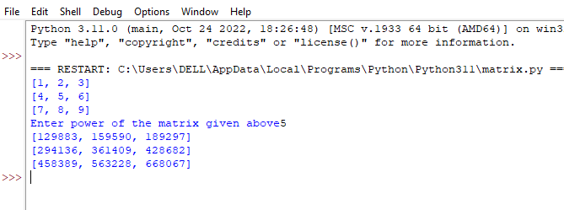

**Conclusion:**

Defined functions prevents keeping writing a code while programming when afunction is required multiple times e .g function for multiplying matrices is required severally hence one can just create it and then keep calling it.